## 

## 

|  |
| --- |
| **International School**  CAPSTONE PROJECT 2  **CMU-SE-451**  Architecture Document  v 1.5  GreenBig5 Information System  Submitted by  Loc, Nguyen Tien  Chung, Hoang Bao  Vinh, Do Quang  Kha, Ngo Van  **Approved by**  **Capstone Project 2 - Mentor:**  Name Signature Date  Nguyen Thanh Binh  15.05.2022 |

|  |  |  |  |  |
| --- | --- | --- | --- | --- |
| **Project acronym** | GB5 | | | |
| **Project Title** | GreenBig5 | | | |
| **Start Date** | 01-Mar- 2022 | **End Date** | | 16- May- 2022 |
| **Lead Institution** | International School, Duy Tan University | | | |
| **Project Mentor** | Doctor. Habil. Binh, Thanh Nguyen | | | |
| **Scrum master / Project Leader & contact details** | Loc, Nguyen Tien  Email: nguyentienloc18122000@gmail.com  Tel: 0932478789  Student ID: 24211202217 | | | |
| **Partner Organization** | N/A | | | |
| **Project Web URL** | N/A | | | |
| **Team members** | Student ID | Name | Email | Tel |
| 24211207051 | Chung, Hoang Bao | Baochunga1@gmail.com | 0975059021 |
| 24211208568 | Vinh, Do Quang | doquangvinh0708co@gmail.com | 0937519169 |
| 24211210573 | Kha, Ngo Van | ngokha437@gmail.com | 0935950384 |

|  |  |  |  |
| --- | --- | --- | --- |
| **DOCUMENT INFORMATION** | | | |
| **Document Title** | Architecture Document | | |
| **Author(s)** | Team C2SE.32 | | |
| **Role** | [GB5] Architecture_v1.5 | | |
| **Date** | 25 -Feb- 2022 | File name | [GB5] Architecture_v1.5 |
| **URL** | N/A | | |
| **Access** | Project and CMU Program | | |

## REVISION HISTORY

|  |  |  |  |  |
| --- | --- | --- | --- | --- |
| **Version** | **Person(s)** | **Date** | **Description** | **Approval** |
| Draft | Kha | 25 – Feb - 2022 | Initiate document | x |
| 1.0 | All members | 4 - April – 2022 | Finish content of document | x |
| 1.1 | All members | 6 – April - 2022 | Update content | x |
| 1.1.1 | Kha, Chung | 7 - April - 2022 | Add System Context, Container Diagram, | x |
| 1.1.2 | Kha, Chung | 10 - April - 2022 | Add Component, Class Diagram | x |
| 1.1.3 | Vinh, Loc | 12 - April – 2022 | Add Quality Attributes | x |
| 1.2 | All members | 15 - April - 2022 | Update Container Diagram | x |
| 1.3 | Chung | 17 - April - 2022 | Add Allocation Diagram | x |
| 1.4 | Kha | 20 – April -2002 | Update Components Diagram | x |
| 1.5 | Chung, Kha, Vinh | 16 – May - 2022 | Add Location-Based Generate Question, Decision Tree, Update Component Diagram of Single Page | x |
|  |  |  |  |  |
|  |  |  |  |  |
|  |  |  |  |  |

## 

# 

# TABLE OF CONTENTS

REVISION HISTORY 2

**TABLE OF CONTENTS**3

**INTRODUCTION**4

PURPOSE 4

DEFINITIONS, ACRONYMS AND ABBREVIATIONS 4

DOCUMENTS REFERENCES 5

**PROBLEM STATEMENT**5

PROJECT OVERVIEW 5

BUSINESS DRIVERS 5

Business problem: 5

Business need: 6

PROJECT GOAL 6

**ARCHITECTURE DRIVERS** **Error! Bookmark not defined.**

HIGH-LEVEL REQUIREMENTS 6

SYSTEM CONTEXT DIAGRAM 7

QUALITY ATTRIBUTES 7

**CONSTRAINTS**8

BUSINESS CONSTRAINTS 8

TECHNICAL CONSTRAINTS 8

**HIGH-LEVEL ARCHITECTURE**9

CONTAINER DIAGRAM **Error! Bookmark not defined.**

COMPONENT DIAGRAM 10

CLASS DIAGRAM 13

ALOWCATION DIAGRAM 14

**REFERENCES** **15**

# 

# INTRODUCTION

## PURPOSE

The purpose of the Architecture document is to:

* Define the architecture needs and technology in detail.
* Provide solutions for business needs.
* Provide overview about resources, schedule, solution and budget for the project.

The architecture merely introduces the project to the student development teams, and provides the up-front information necessary for the team to develop a specification.

## DEFINITIONS, ACRONYMS AND ABBREVIATIONS

* + 1. Definitions and Acronyms

|  |  |
| --- | --- |
| **Acronyms** | **Definitions** |
| GB5 | Green Big 5 Information System |
| GUI | Graphical User Interface |
| SDK | Software Development Kit |

* + 1. Diagram Key/Legend

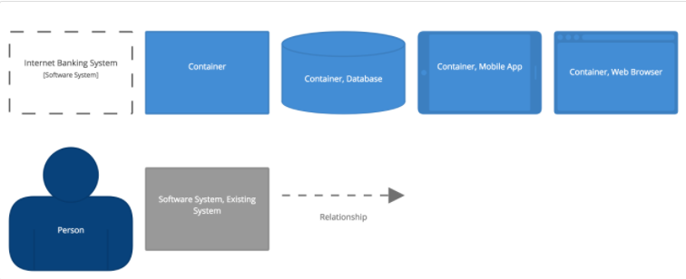

**Figure 1.2.2:** *Diagram Key/Legend*

## DOCUMENTS REFERENCES

|  |  |
| --- | --- |
| **No.** | **Reference** |
| 1 | Product Backlog Document for GB5 |
| 2 | Project Plan Document for GB5 |

# PROBLEM STATEMENT

## PROJECT OVERVIEW

As well as the evolution of The Fourth Industrial Revolution (4IR) and the increasing civilization, the environment is becoming harmful by human behavior. Also, at the current rate of urbanization and industrialization, outside of the natural factors, the change of environment is mainly due to human factors. Emissions, population explosion, industrial solid waste, ... are the main causes leading to negative effects on the global environment. To reduce this at a holistic level, predicting human personality and finding the link between it and the environmental impact is the most important task that must be done.

However, predicting human personality and finding the link between it and the environmental impact from many different sources takes a lot of effort and money. To solve this problem, based on our knowledge of big data systems, we have built an intelligent data processing system that can be run on a website-platform with an intuitive and easy-to-use dashboard. This system is a prospective and useful tool for environmental experts and policy makers in Vietnam in particular, and worldwide in general. It can predict user personality and find their effect on the environment and suggest the solution to reduce it.

## BUSINESS DRIVERS

#### Business problem:

Our environment is always changing. However, at the current rate of urbanization and industrialization, outside of the natural factors, the change of environment is mainly due to human factors. Emissions, population explosion, industrial solid waste, ... are the main causes leading to negative effects on the global environment. To address this at a holistic level, find out the collaboration between human personality and environmental impact is one of the most important missions.

#### Business need:

Green Big 5 Information System have specific uses:

* Collecting user data
* Predicting user personality trait
* Predict Big5 traits and environmental impacts based on linkings between Big5 traits and environmental ontologies.

All the things above are based on the functionality of the Green Big5 Information System. GB5 fully meets these requirements. Therefore, the development of GB5 is very necessary and meaningful.

## PROJECT GOAL

The aim of this project is to build a GreenBig 5 information system (GB5), i.e., GB5 App, database and GB5 Dashboard:

* GB5 Dashboard: Support for create question packages which used to direct the user follow the environment theme. With each question, users can be distributed by Indicator (2). Finally, by using a prediction method to predict the user's personality traits (3) and predicts linkings between big5 traits and environmental impacts.

Implemented through 3 steps:

1. Expert models: expert users use the dashboard to specify the linkings between big traits -facets and environmental keywords structured in tree formats.
2. Questions are defined and generated based on the expert model (1).
3. Predict and verify expert model by using answer results of (2), Based on that. we can verify if the expert model is apllied for which group(s) of users.

* GB5 App (Update): GB5 Application receives user activity data by listening to the event, the state, of the system emitted through Intent so that the system can find out the user’s location based.

As a result, government authorities, enterprises, as well as users would have an overview of the environment and have a better solution to change user behaviour and to reduce and prevent it from the bad effect.

# ARCHITECTURE DRIVERS

## HIGH-LEVEL REQUIREMENTS

*(Refer to the Product Backlog document for GB5)*

## SYSTEM CONTEXT DIAGRAM

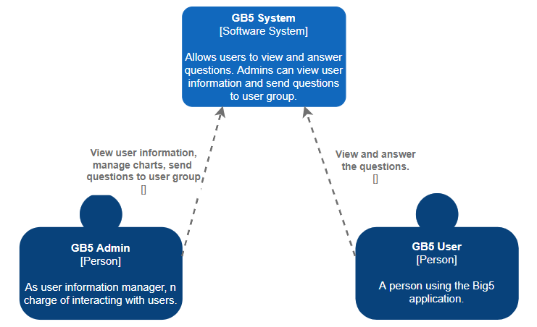

**Figure 3.2**: Context Diagram of System

## QUALITY ATTRIBUTES

|  |  |
| --- | --- |
| **ID** | **QA01** |
| **Quality Attributes** | Performance |
| **Stimulus** | Submit a question to the user group |
| **Source(s) of stimulus** | Admin |
| **Artifacts** | System |
| **Environment** | Normal mode |
| **System response** | The system displays a message that the question has been sent successfully |
| **Response measure(s)** | Within 5 seconds |

**Table 3.3.1:** Quality Attributes: Performance

|  |  |
| --- | --- |
| **ID** | **QA02** |
| **Quality Attributes** | Performance |
| **Stimulus** | Login in to the mobile application |
| **Source(s) of stimulus** | User |
| **Artifacts** | System |
| **Environment** | Normal mode |
| **System response** | The system displays the question view page |
| **Response measure(s)** | Within 3 seconds |

**Table 3.3.2:** Quality Attributes: Performance

|  |  |
| --- | --- |
| **ID** | **QA03** |
| **Quality Attributes** | Availability |
| **Stimulus** | Unable to import question into database |
| **Source(s) of stimulus** | Admin |
| **Artifacts** | System |
| **Environment** | Normal mode |
| **System response** | System will log the fault immediately |
| **Response measure(s)** | Within immediately |

**Table 3.3.3:** Quality Attributes: Availability

# CONSTRAINTS

## BUSINESS CONSTRAINTS

* Project will be started on 01 – Mar – 2022
* Project will be finished on 15 - May - 2022
* Duration: 17 weeks

## TECHNICAL CONSTRAINTS

Main Programming Language: Javascripts, Flutter.

* **GB5 Application:**
  + Programming Language: Dart, Flutter.
  + Tool: Android studio.
* **GB5 Database:**
  + Programming Language: NodeJs.
  + Database: MongoDB.
  + Tool: Visual studio code.
* **GB5 Dashboard:**
  + Programming Language: NodeJs, ReactJs.
  + Tool: Visual studio code.
* **AI Model:**
  + Programming Language: Python.
  + Libraries: sklearn, pandas, pydotplus, fastapi, …
  + Tool: Visual studio code, Pycharm.

# HIGH-LEVEL ARCHITECTURE

## ARCHITECTURE OVERVIEW

**Figure 5.1:** *Architecture Overview*

## CONTAINER DIAGRAM

The diagram below shows the overview architecture including containers.

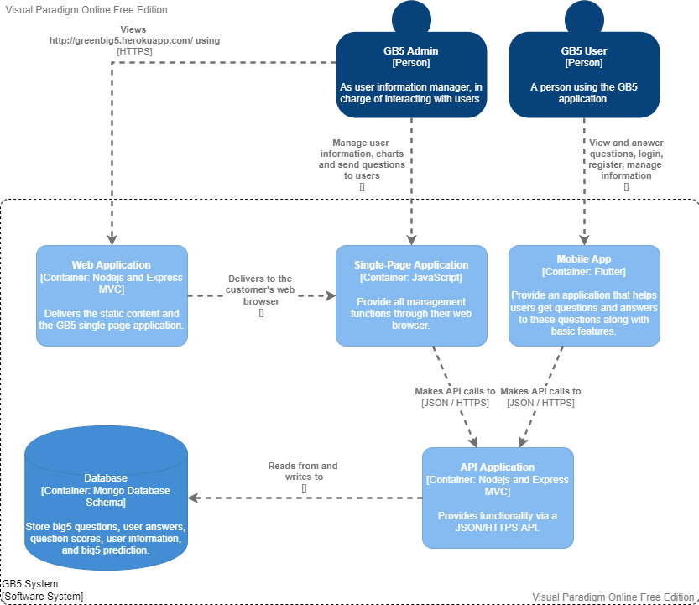

**Figure 5.2:** *Container Diagram*

## COMPONENT DIAGRAM

* + 1. Single-Page Application

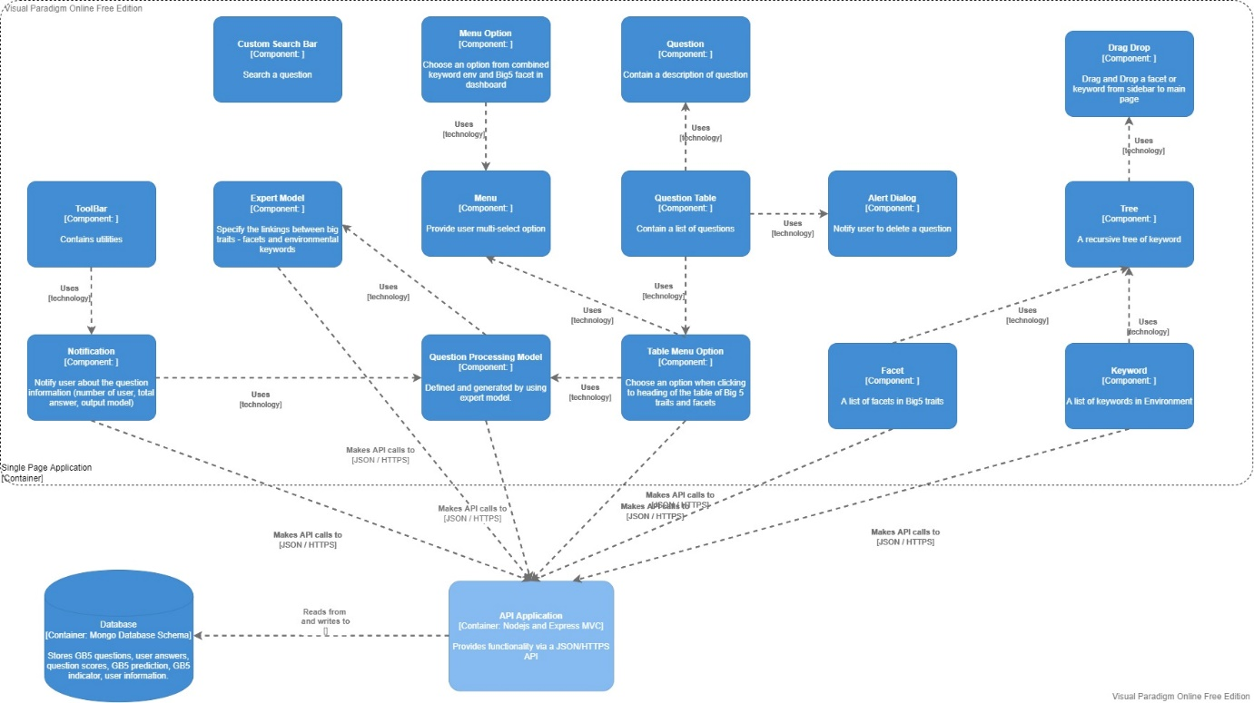

**Figure 5.3:***Component diagram of Single-Page Application*

* + 1. Mobile Application (Update)

The diagram below shows the overview architecture including components and other related components.

## 

**Figure 5.4:***Component diagram of Mobile Application*

## CLASS DIAGRAM

The diagram below shows the overview architecture including the class diagram of the question management component.

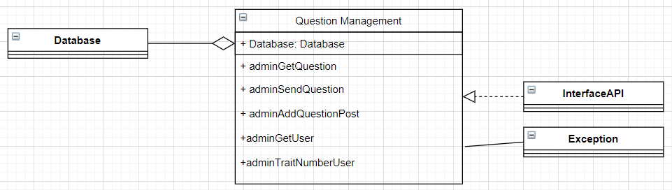

**Figure 5.5:** *Class Diagram*

|  |  |
| --- | --- |
| **Role & Responsibility** | **Description** |
| adminGetQuestion | Display questions from the database on the board |
| adminSendQuestion | Submit a question to the user group |
| adminAddQuestionPost | Enter the question into the database |
| adminGetUser | Select the User group to submit the question |
| adminTraitNumberUser | Save indicator information for group classification |

# 5.4 Allocation Diagram

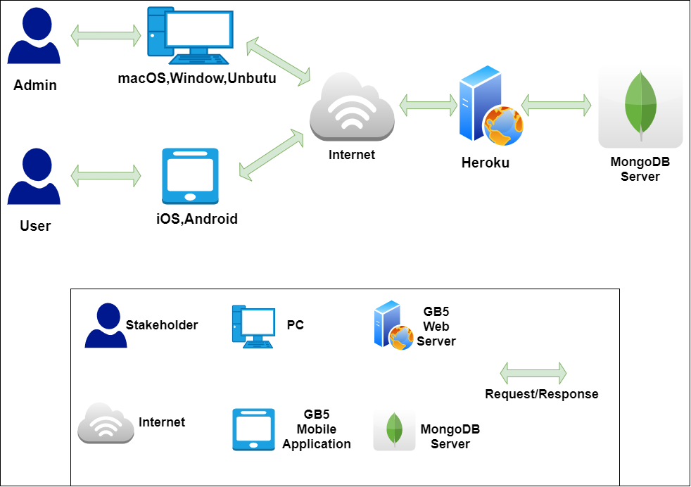

**Figure 5.4:** *Allocation Diagram*

|  |  |
| --- | --- |
| **Role & Responsibility** | **Description** |
| Admin | Admin who interact with GB5 Dashboard Application. |
| User | User who interact with GB5 Mobile Application. |
| PC | Devices providing web browsers. |
| GB5 Mobile Application | The device that provides the operating environment for the GB5 application. |
| Internet | A global computer network providing a variety of information and communication facilities, consisting of interconnected networks using standardized communication protocols. |
| GB5 Web Server | This is where the API is hosted and provides hosting... |
| MongoDB | Database server to store data. |
| Request/Response | Get request data from client and response the data to client. |

# LOW-LEVEL ARCHITECTURE

# 6.1 Location Based

When the user allows the app to access the location. It is provided by GeoLocator service. The app uses the GeoLocator service to get the current location Latitude and Longitude. Then use GeoCoding service to convert Latitude and Longitude locations received from GeoLocator to addresses which you will have information in details such as street, locality, country ...

These location attributes can be used as features that provide validation of human interactions with the environment.

# 6.2 Generate Question

First, user need to choose a facet of trait, and a keyword environment. It will automatically combine to the tree and just click the keyword in the tree they want and select it. The table will display and user select Generate Question option. It will take a little bit time. The flow is:

* The Keyword Big5 Environment will send to NodeJS server and sanitize the request payload, and call an API to Python server for handling more complex algorithm
* The sanitized input should be an array like this [Keyword Env, Facet]
* I will extract each word from array and find the synonyms, because I also have a question generation by text or keyword, so we can train and generate more question from text too and push to database. So that the reason why we find synonyms for each keyword and save it in a ‘Tags’ of each question generated for searching and analyzing the meaning of the question which has been trained from text or keyword before. I did it because I think we’ll used it in future.
* After have a list of tag, for each key in input array I generate some related text sentence from it. And combine all text sentence together and from that I generate each question related and push to database and return response to client web

Example:

Keyword: Food

Facet: Ideas

* Question: Do you usually plan a party or a trip?
* Keyword Big Five Environment: Food Ideas
* Tags: [Food, Ideas, Fruit, Apple, Plan]
* Point: Point High = 20, Point Medium = 15, Point Low = 10
* Personality: Openness = Medium, Conscientious = Low, Extraversion = High, Agreeable = Low, Neuroticism = Low.

# 6.3 Decision Tree

To predict the correctness of the flow generated from the keyword, we use the decision tree algorithm.

* How does the Decision Tree algorithm work?

The basic idea behind any decision tree algorithm is as follows:

* + Select the best attribute using Attribute Selection Measures (ASM) to split the records.
  + Make that attribute a decision node and breaks the dataset into smaller subsets.
  + Starts tree building by repeating this process recursively for each child until one of the conditions will match:
    - All the tuples belong to the same attribute value.
    - There are no more remaining attributes.
    - There are no more instances.

* Some formulas need to be calculated in the decision tree:
  + Information Gain

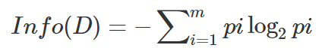

* + Gain Ratio

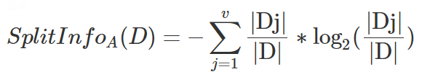

* + Gini index

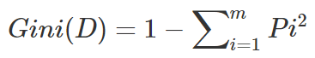

* How do we use this algorithm?
* The data set after the study is obtained as follows:

* Using the decision tree algorithm, we get the following:

* After performance opt imization:

* From here we can predict whether the newly created flow is true or false with up to 78% accuracy.

# REFERENCES

* [The C4 model for visualising software architecture](https://c4model.com/#Metamodel)
* <https://online.visual-paradigm.com/>
* [diagrams.net](https://app.diagrams.net/)
* <https://protocoderspoint.com/flutter-get-current-location-address-from-latitude-longitude/>
* <https://codelabs.developers.google.com/codelabs/google-maps-in-flutter#3>
* <https://www.datacamp.com/tutorial/decision-tree-classification-python>